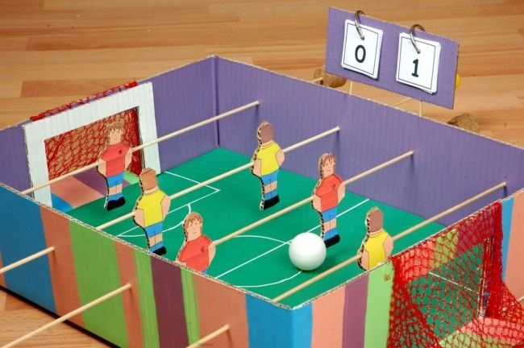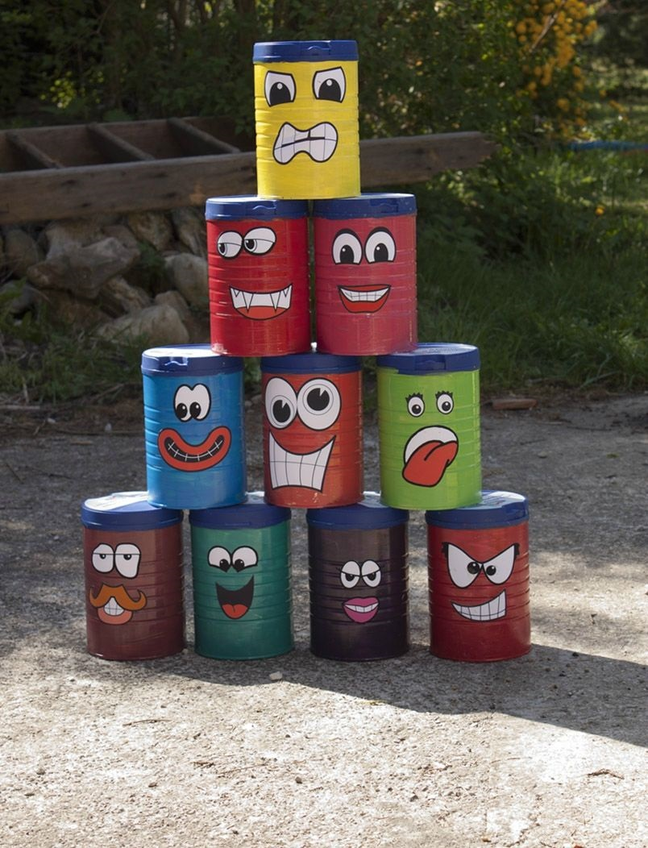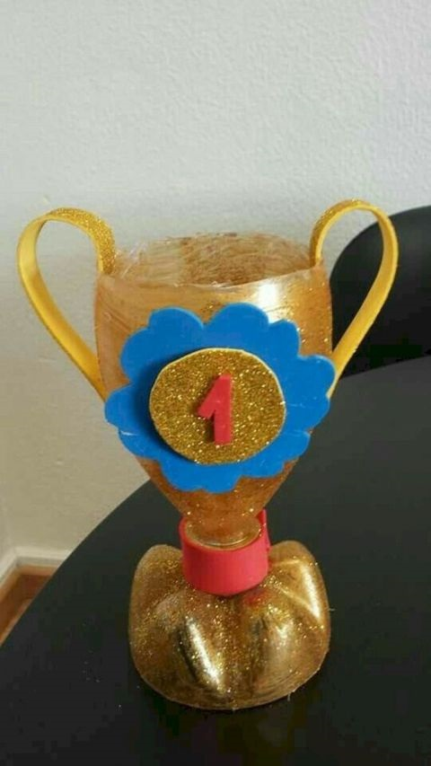

Použité zdroje:
https://www.soeasy-tips.com/2020/02/recycling-easy-to-do-with-children-45.html
http://www.caudissou.fr/la-fete-des-6-ans/
https://www.agirlandagluegun.com/2019/07/what-to-do-with-plastic-pop-cans.html

