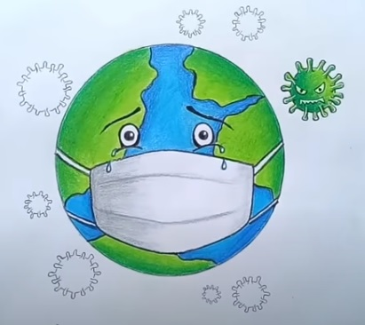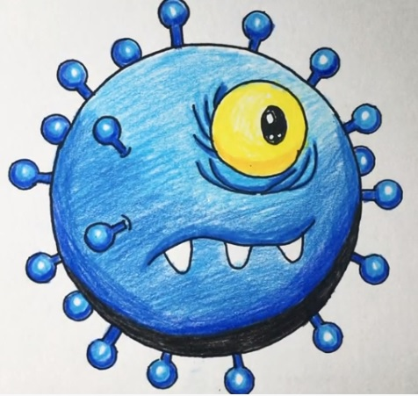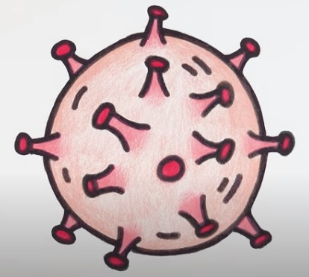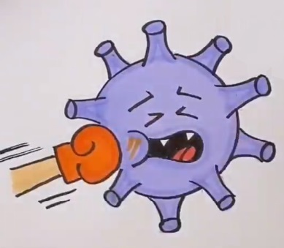

Použité zdroje:
https://www.youtube.com/watch?v=5EmsDVVdnaQ
https://www.youtube.com/watch?v=uDhVtZa-PT8
https://www.facebook.com/KidsArtnCrafts/videos/306078083697779/
https://www.youtube.com/watch?v=dKv0bMnGl4I

