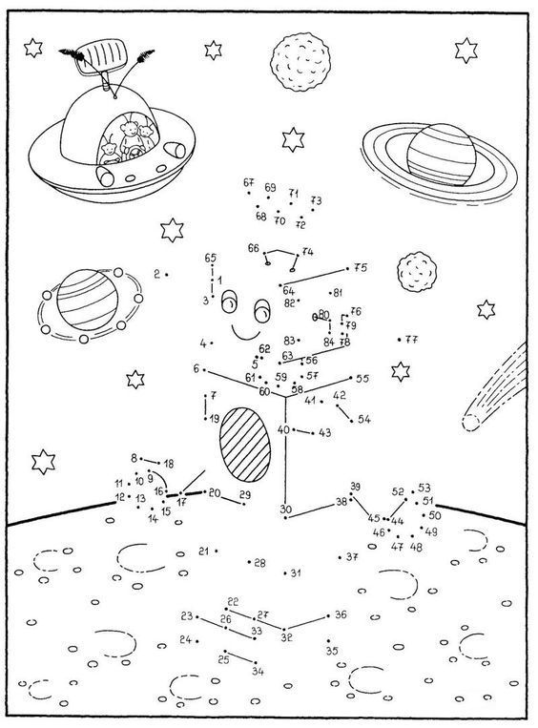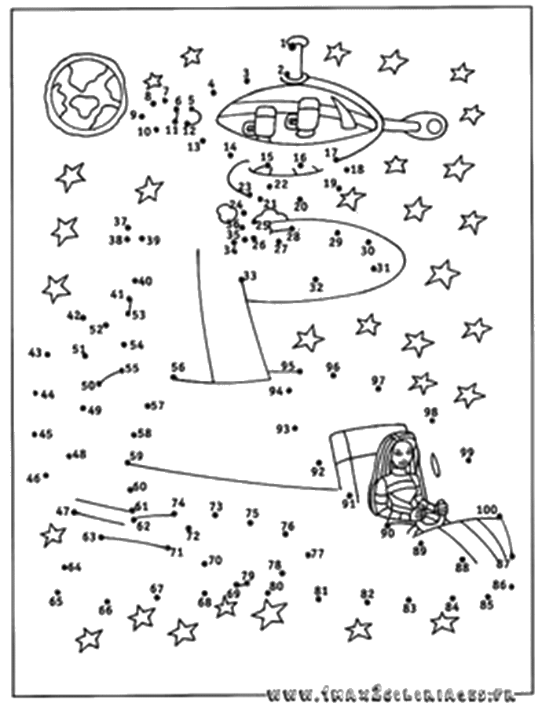[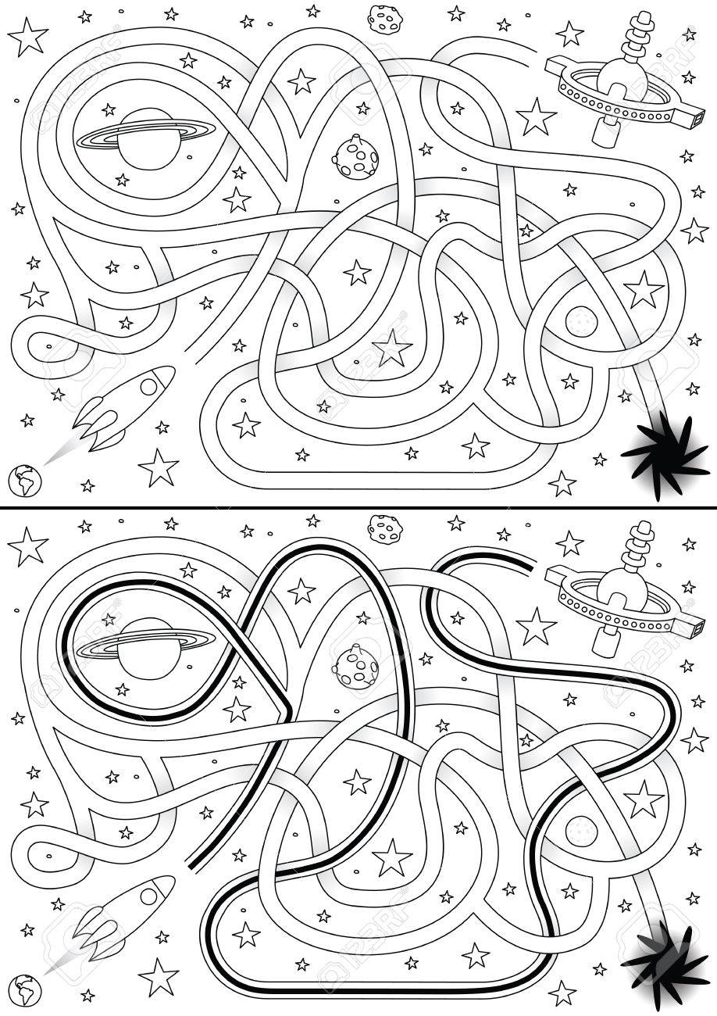](https://www.google.sk/url?sa=i&url=https://www.123rf.com/photo_25331852_space-rocket-maze-for-kids-with-a-solution-in-black-and-white.html&psig=AOvVaw3YLZqnwNx-2YJCnNCS020g&ust=1588844922526000&source=images&cd=vfe&ved=0CAIQjRxqFwoTCJDq5ez6nukCFQAAAAAdAAAAABAe)[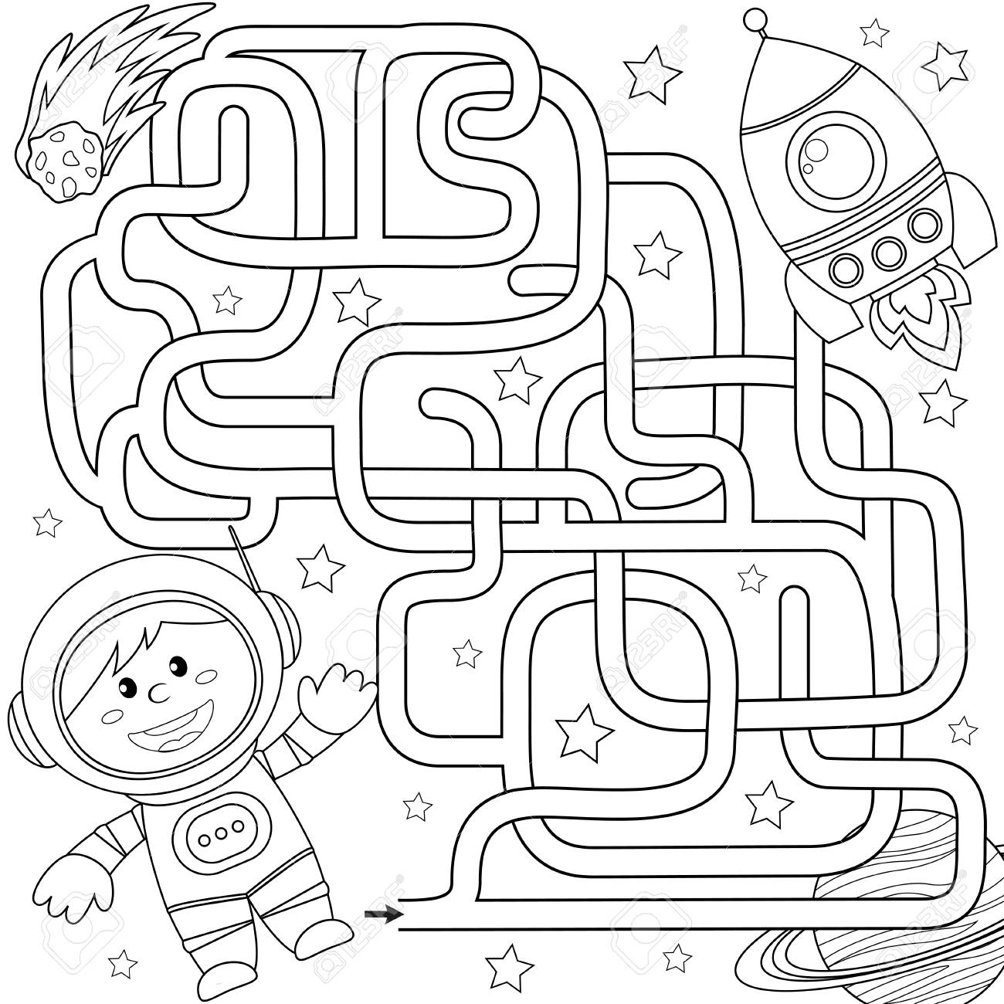](https://www.google.sk/url?sa=i&url=https://www.123rf.com/photo_90215185_stock-vector-help-cosmonaut-find-path-to-rocket-labyrinth-maze-game-for-kids-black-and-white-vector-illustration-.html&psig=AOvVaw3YLZqnwNx-2YJCnNCS020g&ust=1588844922526000&source=images&cd=vfe&ved=0CAIQjRxqFwoTCJDq5ez6nukCFQAAAAAdAAAAABAZ)

**Hľadaj rozdiely**

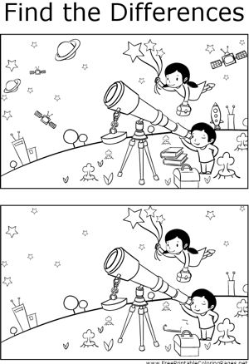

ZDROJE:

<https://www.123rf.com>

<https://www.freeprintablecoloringpages.net>

<https://sk.pinterest.com>