[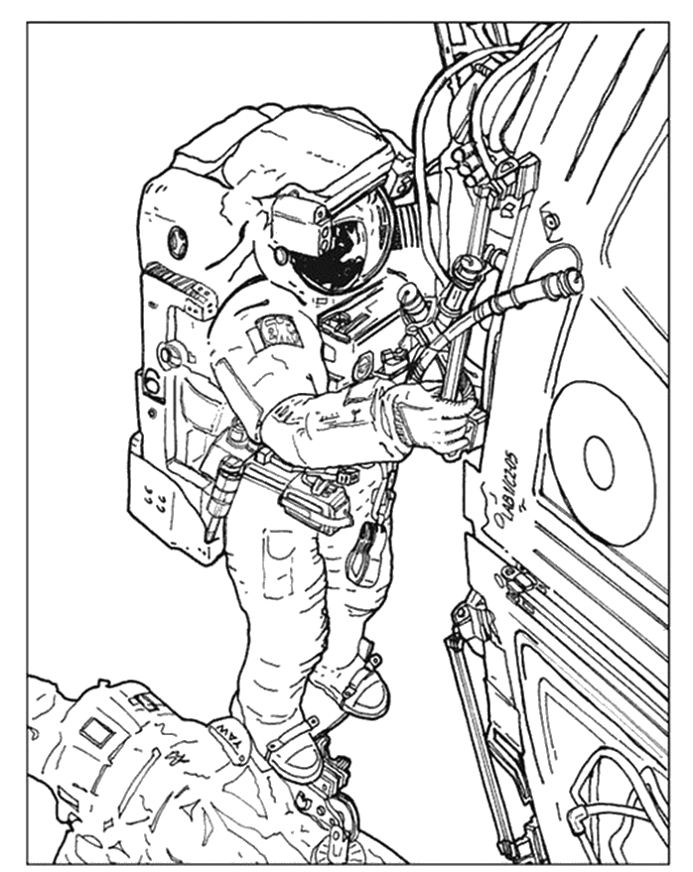](https://www.google.sk/url?sa=i&url=https://www.edupics.com/coloring-page-06-astronauts-in-space-station-i4199.html&psig=AOvVaw3YLZqnwNx-2YJCnNCS020g&ust=1588844922526000&source=images&cd=vfe&ved=0CAIQjRxqFwoTCJDq5ez6nukCFQAAAAAdAAAAABBq)[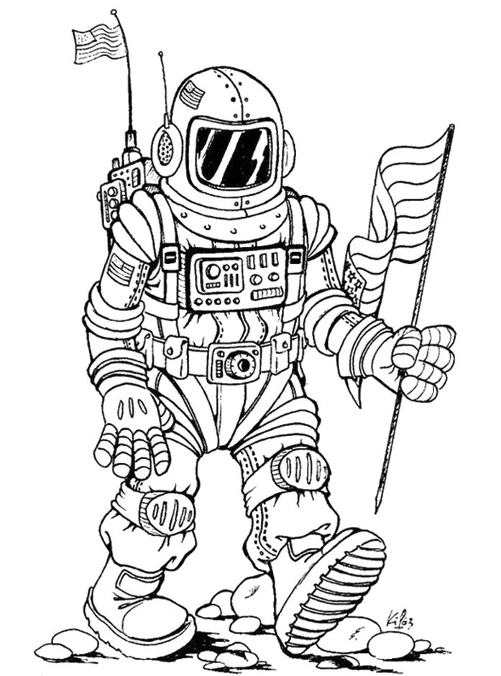](https://www.google.sk/url?sa=i&url=https://www.edupics.com/coloring-page-astronaut-i3954.html&psig=AOvVaw3YLZqnwNx-2YJCnNCS020g&ust=1588844922526000&source=images&cd=vfe&ved=0CAIQjRxqFwoTCJDq5ez6nukCFQAAAAAdAAAAABBm)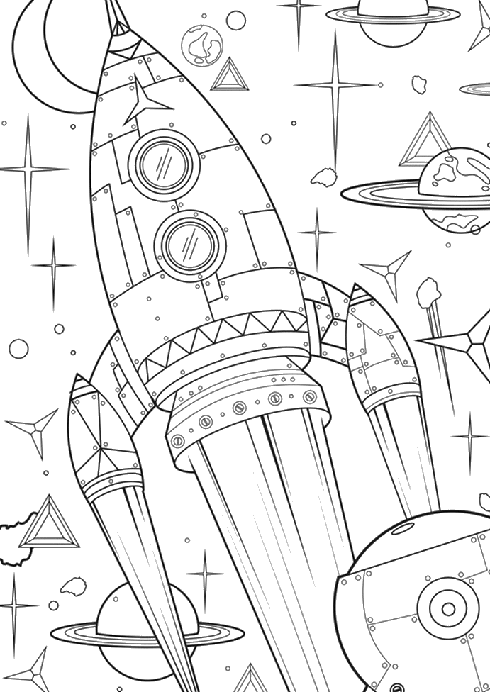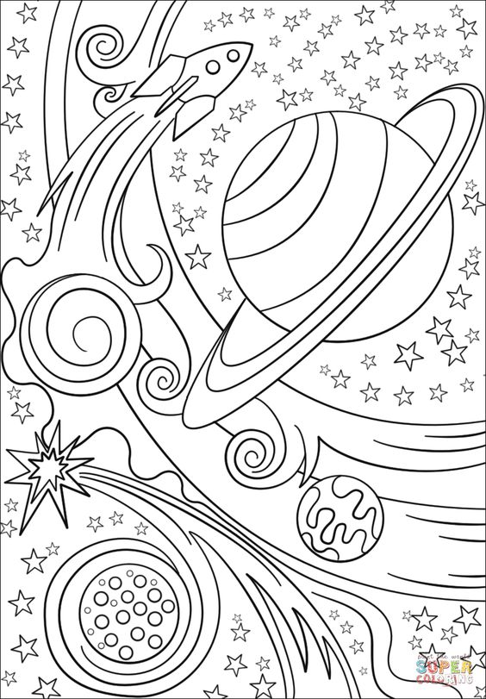

[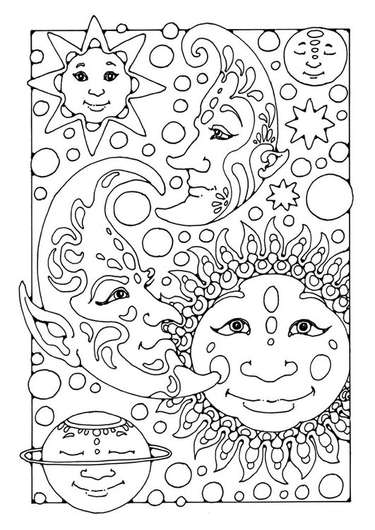](https://www.google.sk/url?sa=i&url=https://www.educima.com/dibujo-para-colorear-sol-luna-y-estrellas-i25665.html&psig=AOvVaw3YLZqnwNx-2YJCnNCS020g&ust=1588844922526000&source=images&cd=vfe&ved=0CAIQjRxqFwoTCJDq5ez6nukCFQAAAAAdAAAAABBF)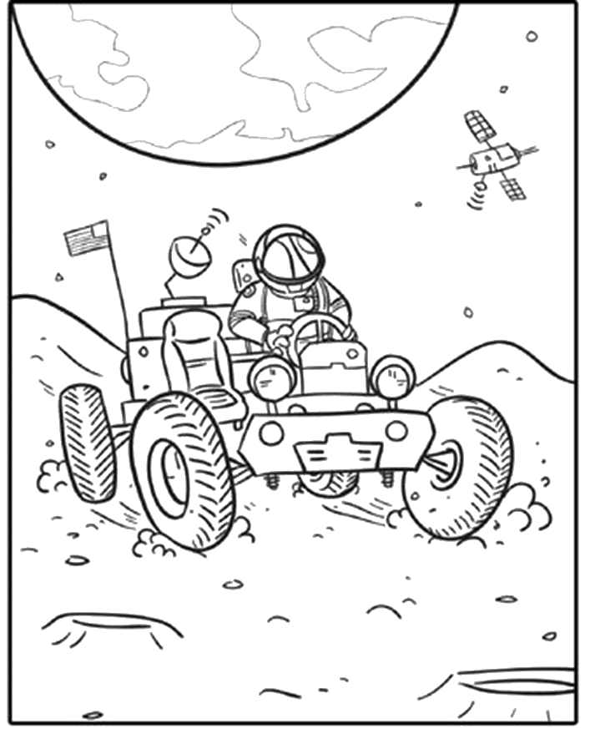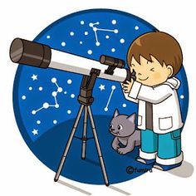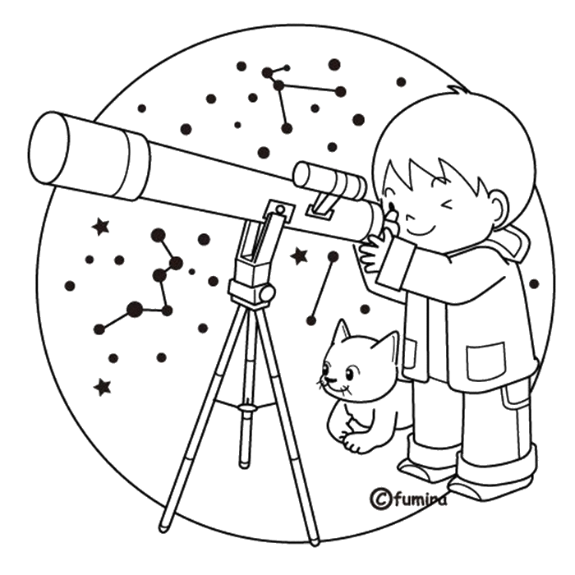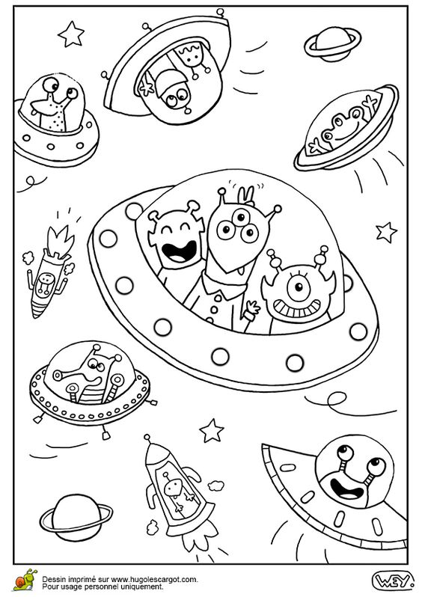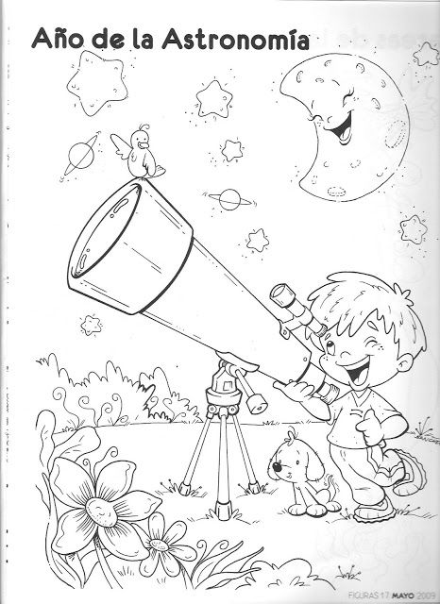[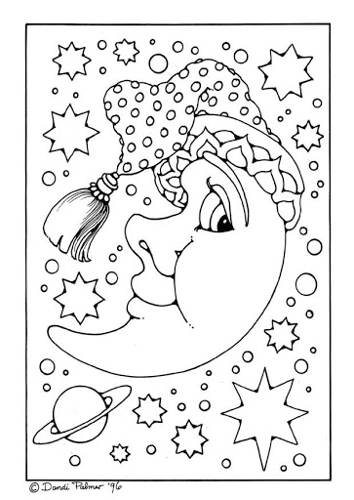](https://www.google.sk/url?sa=i&url=http://clipart-library.com/clipart/19-8iE55yyia.htm&psig=AOvVaw3YLZqnwNx-2YJCnNCS020g&ust=1588844922526000&source=images&cd=vfe&ved=0CAIQjRxqFwoTCJDq5ez6nukCFQAAAAAdAAAAABBK)[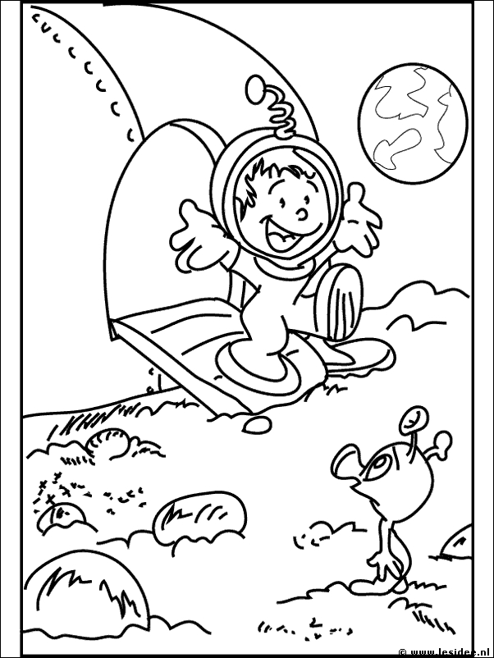](https://www.google.sk/url?sa=i&url=https://www.pinterest.com/paperlovebymeg/spring-fair-space-theme/&psig=AOvVaw3YLZqnwNx-2YJCnNCS020g&ust=1588844922526000&source=images&cd=vfe&ved=0CAIQjRxqFwoTCJDq5ez6nukCFQAAAAAdAAAAABBP)[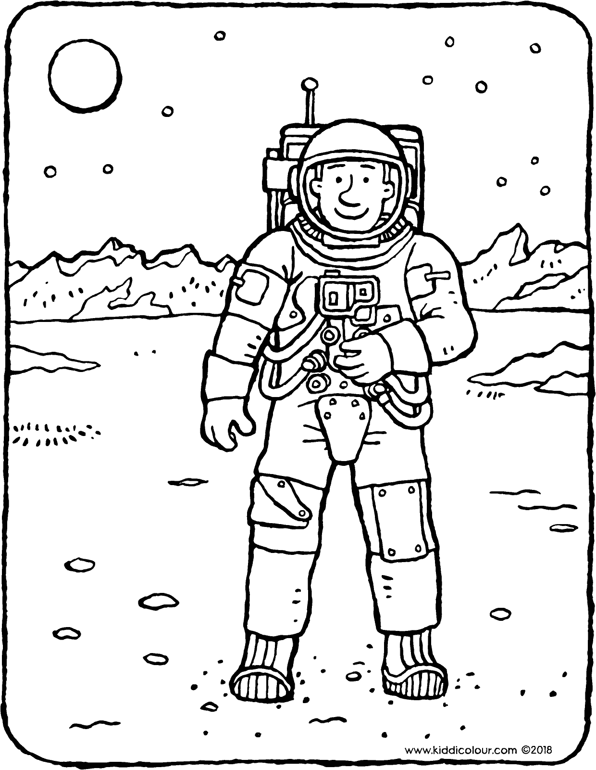](https://www.google.sk/url?sa=i&url=https://kiddicolour.com/colouring-page/astronaut/&psig=AOvVaw3YLZqnwNx-2YJCnNCS020g&ust=1588844922526000&source=images&cd=vfe&ved=0CAIQjRxqFwoTCJDq5ez6nukCFQAAAAAdAAAAABBV)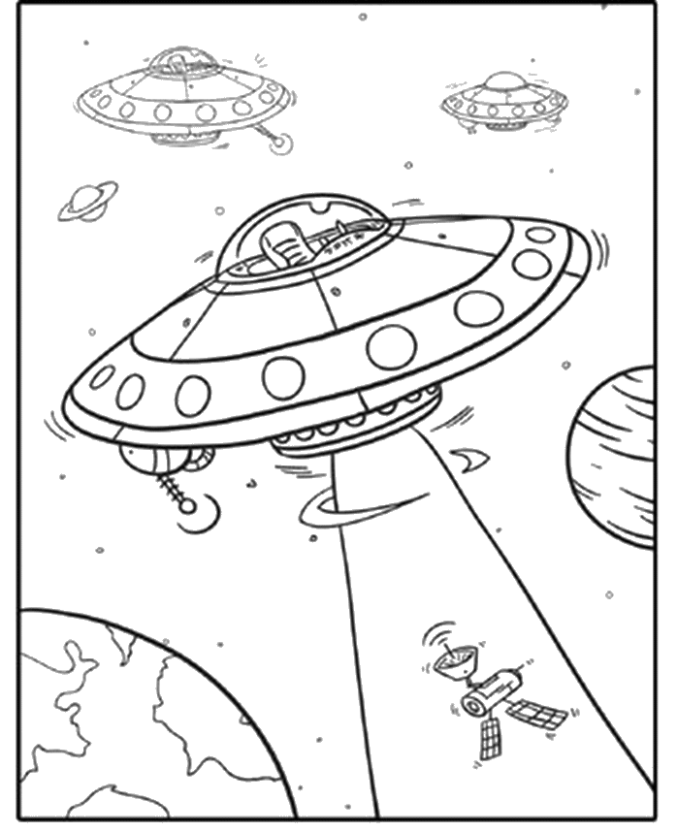 [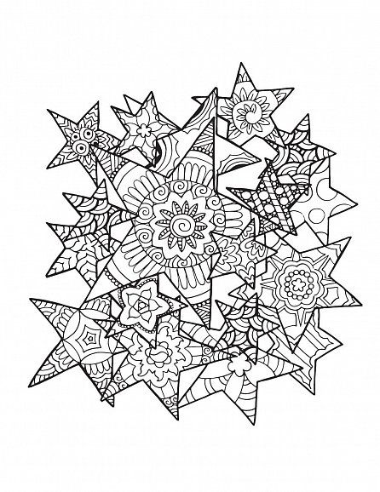](https://www.google.sk/url?sa=i&url=https://www.dobre-knihy.cz/arteterapie-barvy-vesmiru-268977.html&psig=AOvVaw3YLZqnwNx-2YJCnNCS020g&ust=1588844922526000&source=images&cd=vfe&ved=0CAIQjRxqGAoTCJDq5ez6nukCFQAAAAAdAAAAABCpAQ)

ZDROJE:

https://kiddicolour.com

https://sk.pinterest.com

https://www.edupics.com

https://www.clipart-library.com

https://www.educima.com

https://www.google.sk