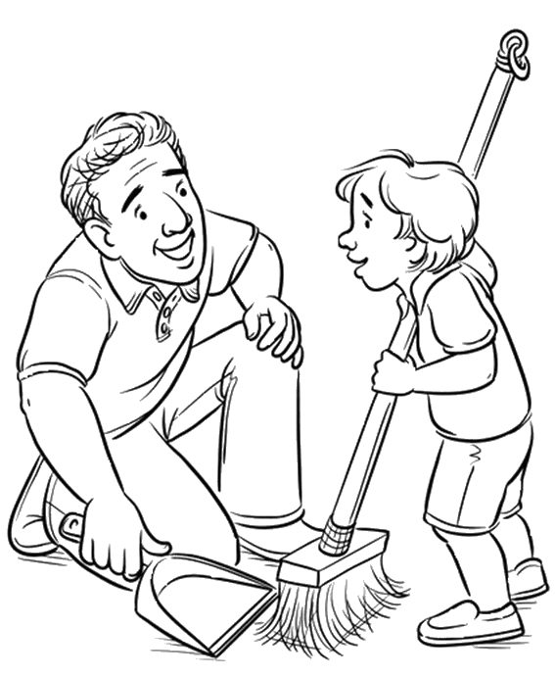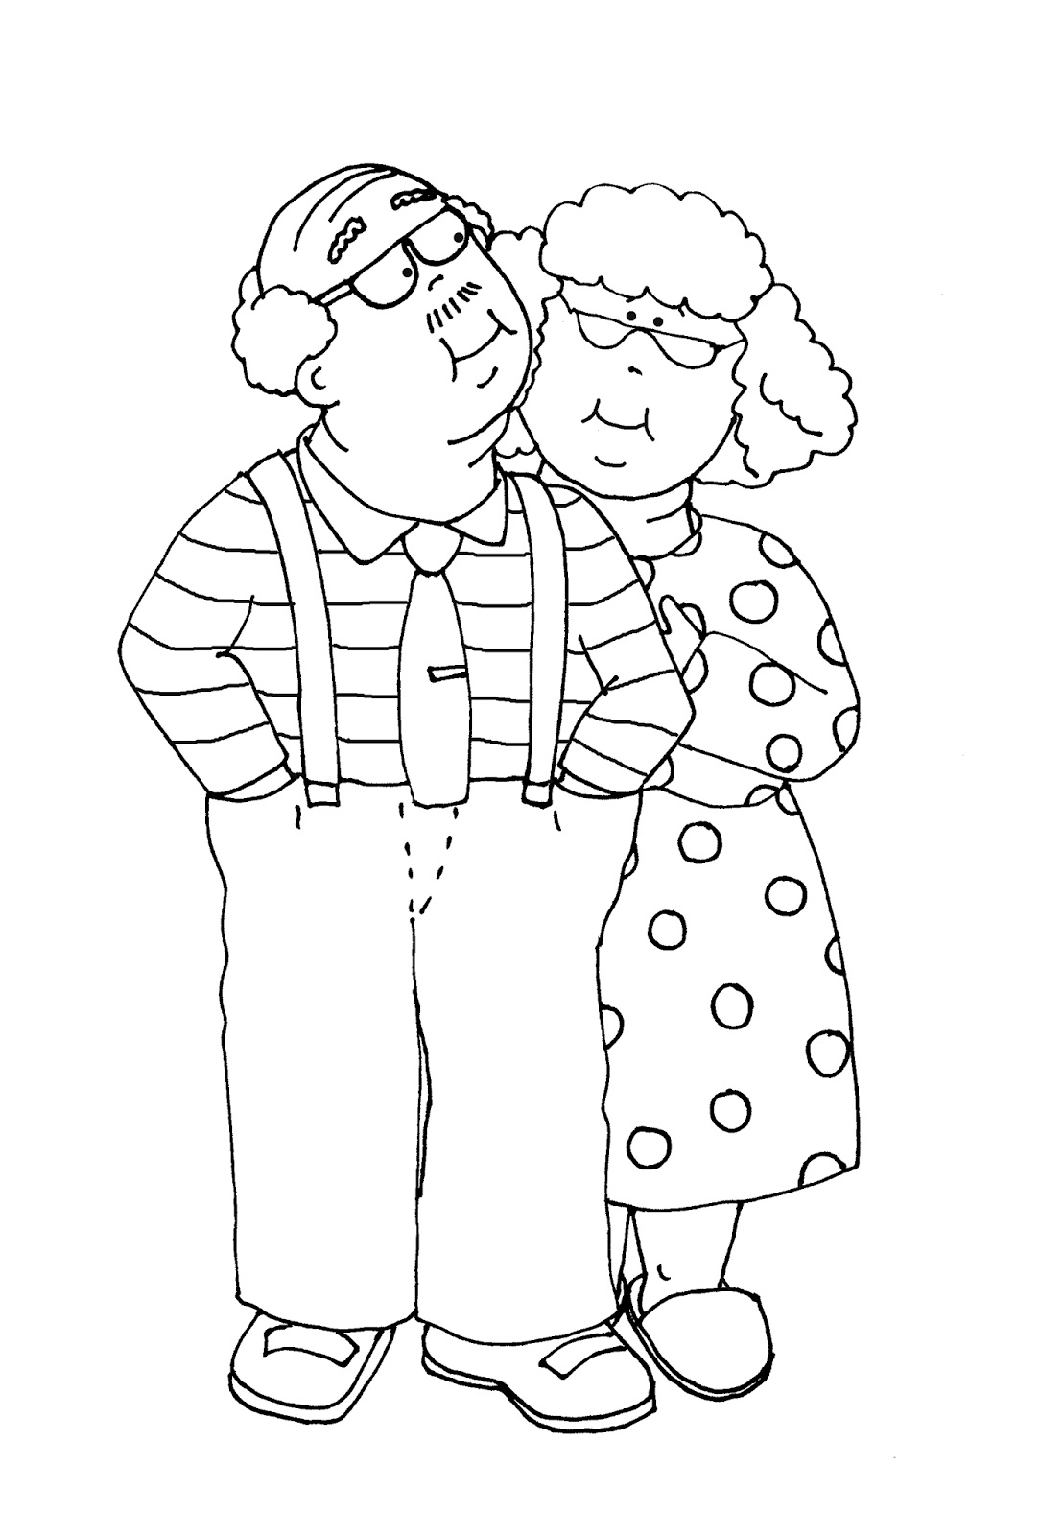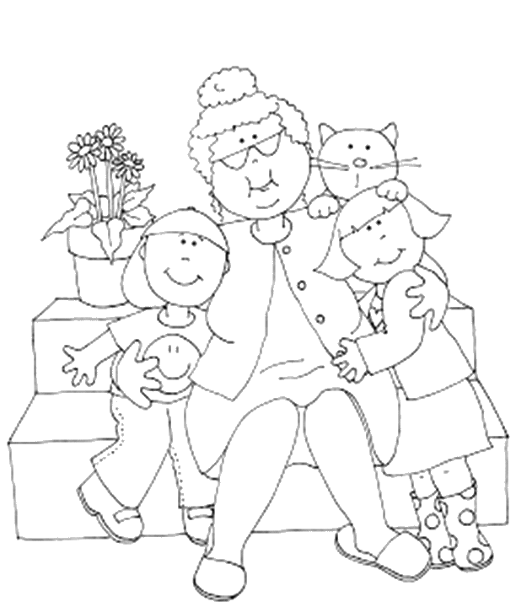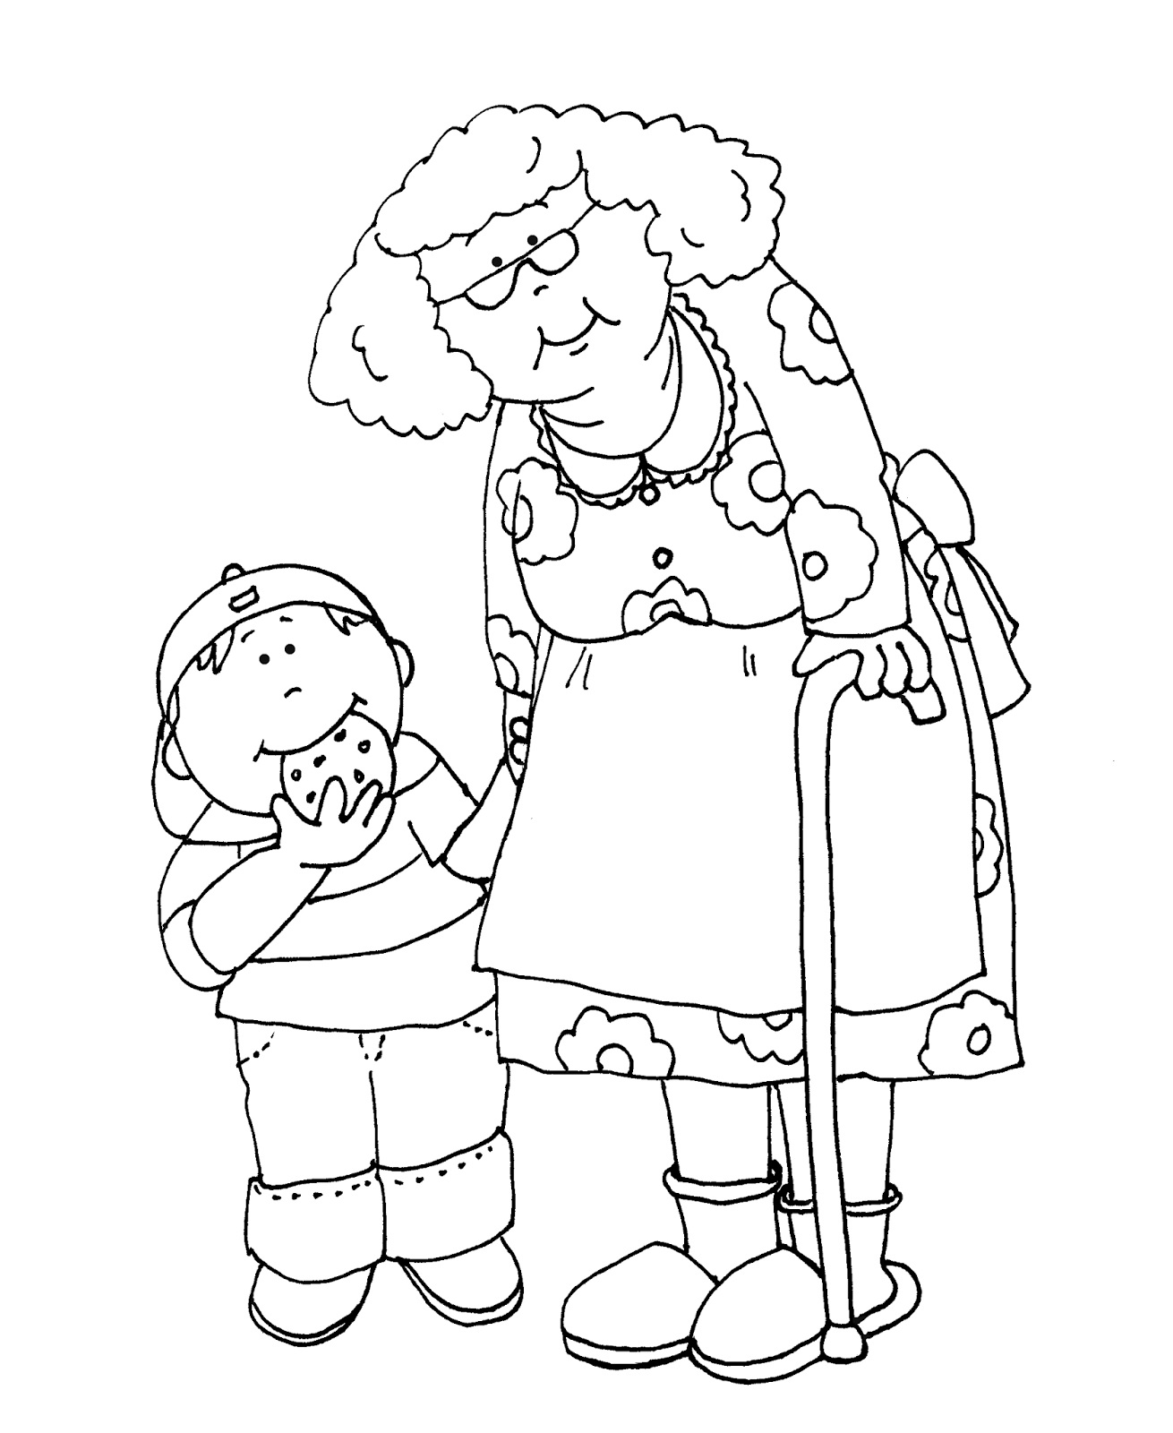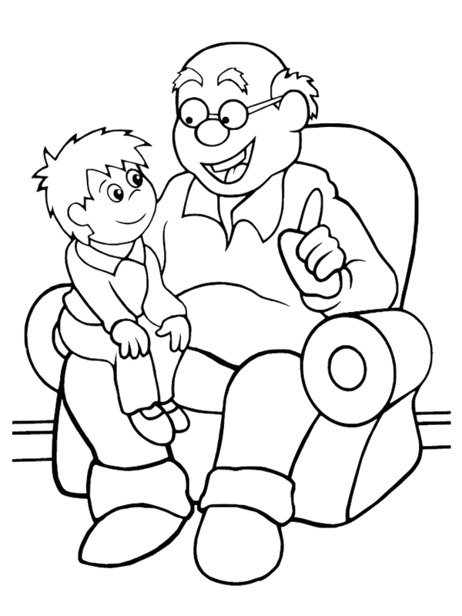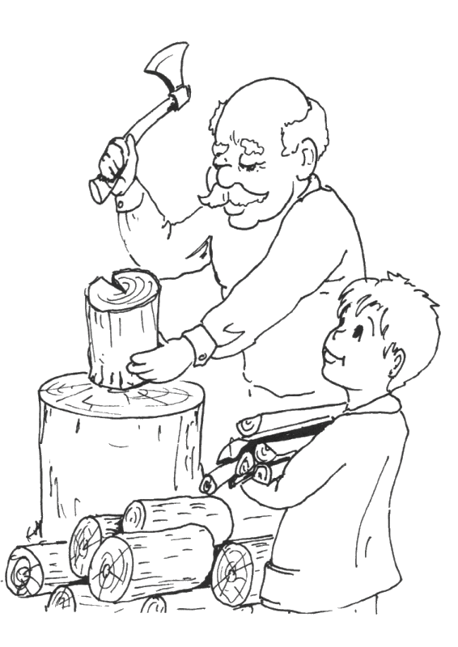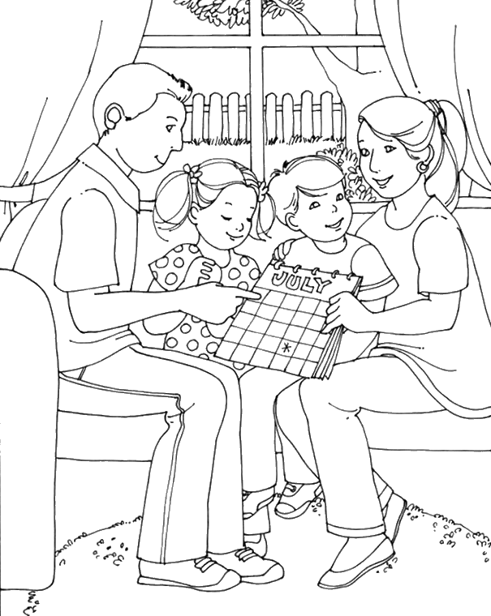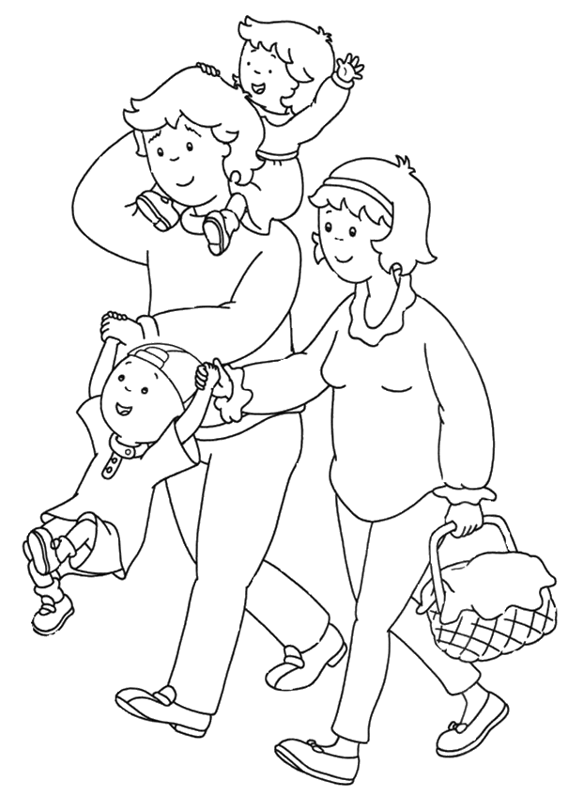

Použité zdroje:
https://www.churchofjesuschrist.org/study/friend/2016/09/coloring-page?lang=eng
http://freedeariedollsdigistamps.blogspot.com/2015/02/grammy-couple-no-kisses.html
http://freedeariedollsdigistamps.blogspot.com/2016/09/as-requestedgrammy-with-boy-and-girl.html
http://freedeariedollsdigistamps.blogspot.com/2015/02/grammys-cookies.html?m=1
https://czasdzieci.pl/kolorowanki/id,105b28-kolorowanki_dzieci_dzien,do_druku,1532d67.html
http://czasdzieci.pl/pliki_dz/kolorowanki/kolorowanka_105_1529.gif
https://i.pinimg.com/originals/a0/79/e8/a079e892fdcdf8375e5f7dd57f08da0f.jpg
https://i.pinimg.com/originals/34/8c/a4/348ca46469d23cf34ef850c6db6eb0d4.jpg

