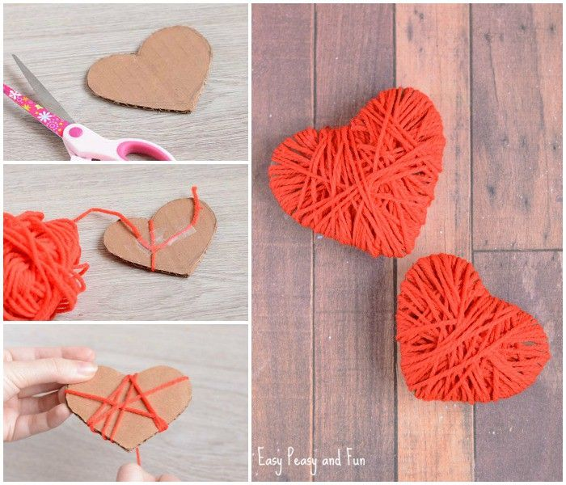

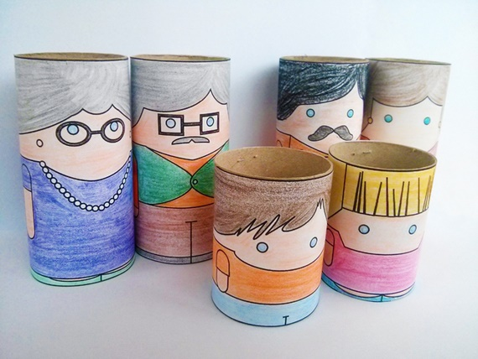
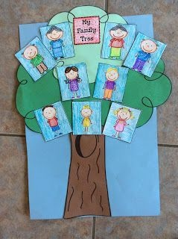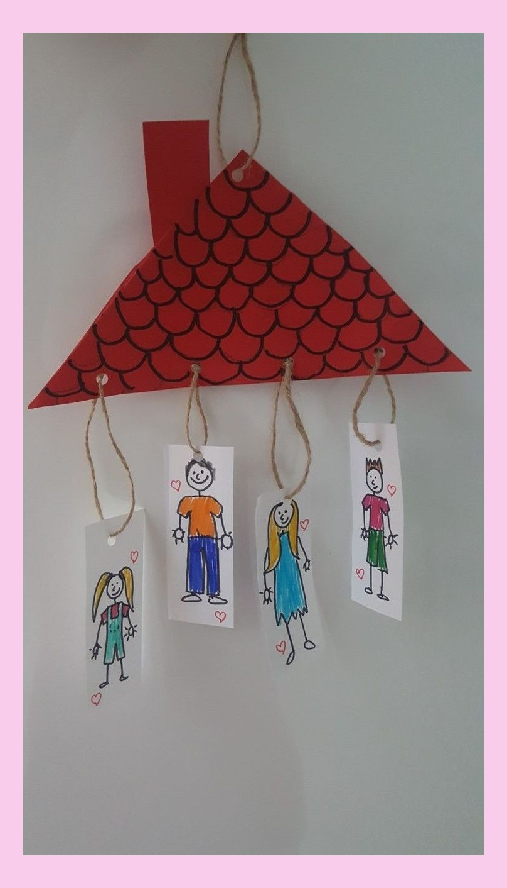
Použité zdroje:
https://craft.turkeytrip.info/129-33-trendy-craft-room-organization-fabric-wrapping-papers/
https://market.marmelada.co.il/ילדים/יצירה-לילדים/קבצים-לפעילות-יצירה-לילדים-משפחה/
http://momstotschool.blogspot.com/2012/05/family-craft.html
http://rickmankara.blogspot.com/2016_06_16_archive.html
https://www.cynicalparent.com/easy-valentines-day-crafts-preschoolers/?utm_medium=social&utm_source=pinterest&utm_campaign=tailwind_tribes&utm_content=tribes&utm_term=278170570_7297050_21813

