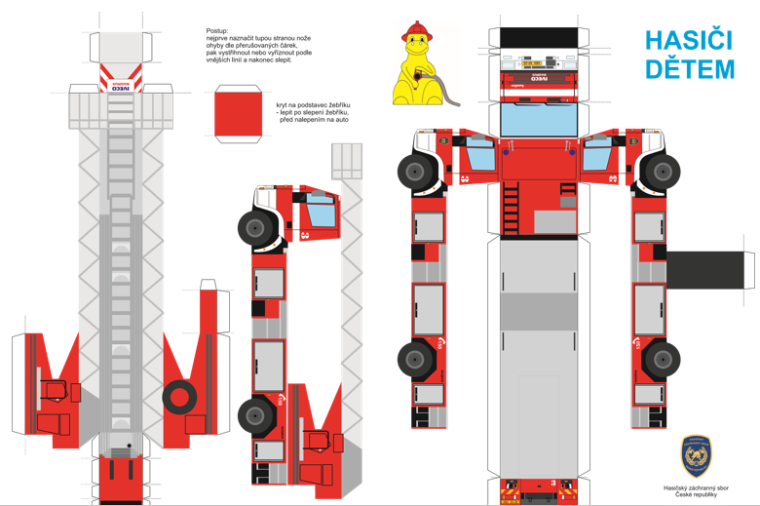
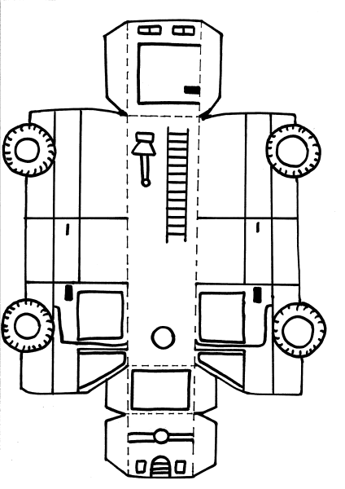
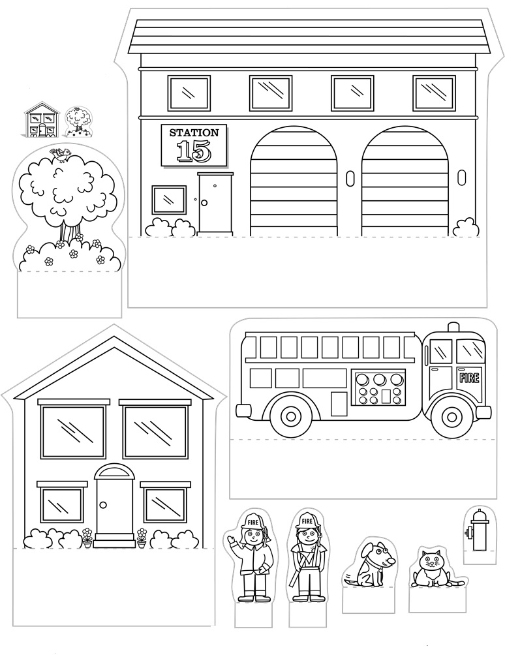
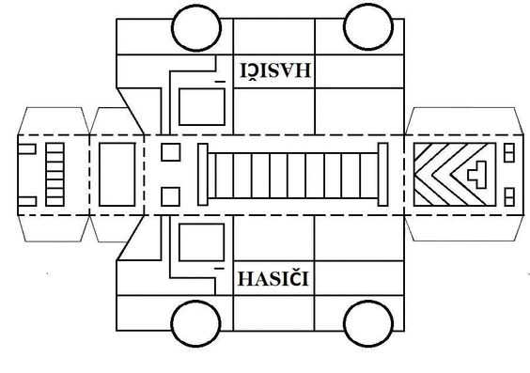

Použité zdroje:
https://www.education.com/download/worksheet/46322/pop-up-neighborhoods-fire-station.pdf
http://hasici.studenec.cz/?p=1123
https://sk.pinterest.com/pin/340655159292885595/

